Bahria University,

Karachi Campus



LAB EXPERIMENT NO.

**06**

LIST OF TASKS

|  |  |
| --- | --- |
| TASK NO | OBJECTIVE |
| 1 | **Write a python program implementing the newton’s difference formula that considers the following data points, and  a. Find the value of y at x = 301  b. Find the value of y at any given user input** |
| 2 | **Write a Python program that implements Newton's difference formula, reads the CSV file 'salary_data,' and considers 'years of experience' as x and 'salary' as y. Then, upon user input for a specific number of years of experience, it provides an output of the salary they would receive.** |
| 3 | **Write a python program implementing the Lagrange interpolation formula that considers the following data points, and find the value of y at x = 7** |

**Task 1: Write a python program implementing the newton’s difference formula that considers the following data points, and   
a. Find the value of y at x = 301   
b. Find the value of y at any given user input**

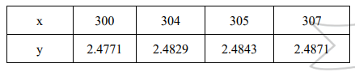

**Solution**

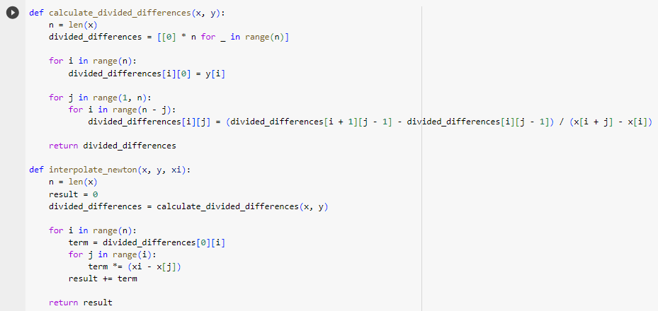

**Task 2: Write a Python program that implements Newton's difference formula, reads the CSV file 'salary_data,' and considers 'years of experience' as x and 'salary' as y. Then, upon user input for a specific number of years of experience, it provides an output of the salary they would receive.**

**Solution**

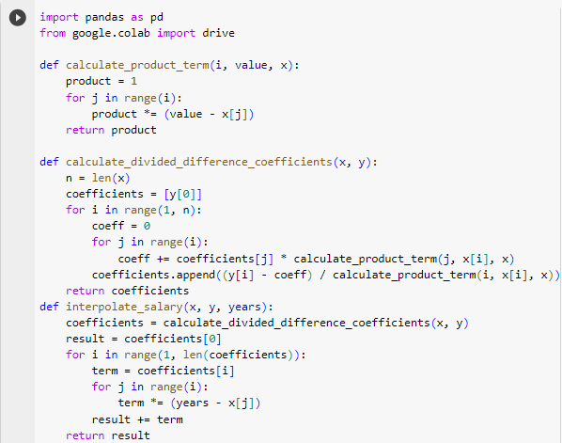

**Task 3: Write a python program implementing the Lagrange interpolation formula that considers the following data points, and find the value of y at x = 7**

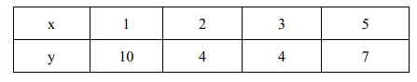

**Solution**

